Day in the Life of the Hudson River 10/14/21
GEORGE FREER MEMORIAL PARK, PORT EWEN
RIVER MILE: 90.5
Salt Front: ~ RM 49
High Meadow School- Gian Ascione and 3 teachers
20 students 8th grade
Latitude 41.910714 N & Longitude – 73.972606 W

Location: George Freer Memorial Park, Port Ewen, New York
Area: Park space with grassy area, used for picnics, fishing and boating.
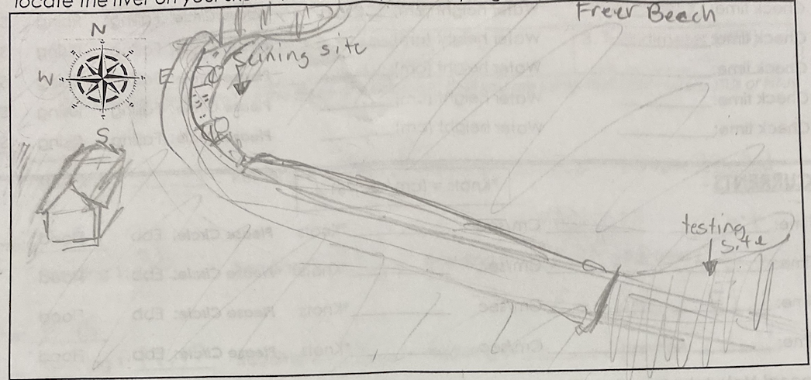
Surrounding Land Use: Urban/Residential; Recreation/Beach
Sampling Site: Grassy; parking lot nearby; light density forest trees nearby (Willow, Oak, staghorn sumac)
Shoreline: Sandy beach; banks partially altered by concrete bulkhead; drainage pipes (2) entering water north of bulkhead; may pieces of brick and coal lay around the beach
Plants in area: Water chestnut seeds
River Bottom: Sandy

ITEM |  | Time |  | Reading |  |  |  |  | Comments
Physical
Air Temperature |  | 11:19 AM  12:06 PM  12:45 PM |  | 30.1 º C  30 º C  28.3 º C |  |  |  | 86.1 º F  86 º F  83 º F
Wind Speed: |  |  |  | 0.1 m/s |  |  |  | Beaufort 0
Weather today |  | 10:45 AM – Mostly cloudy 51-75%
Weather the past 3 days: |  | No rain, sunny and unusually warm. On the 11th , high of 23C / 73 F. On the 12th, high 22C / 72 F. On the 13th, high of 23 C / 73 F
Tides- tide stick |  | Time |  | Rising, Falling, Unchanged |  |  |  | Height (cm)
 |  | 10:58 AM  12:45 PM |  | Falling
Current- |  | Time |  | Cm/sec |  | Knots |  | North/South | Ebb/Flood/Still
 |  | 1:05 PM  10:07 PM  1:17 PM |  | 3.72  5.30  15.91 |  | 0.07  0.10  0.309 |  | South  South  South | Ebb  Ebb  Ebb
Water Temperature- collected from bucket |  | 12:27 PM |  | 20 º C |  |  |  | 68 º F
Turbidity- Long sight tube |  | 11:18 AM  11:52 AM  12:45 PM |  | 26cm, 40.8cm, 32 cm,  35cm, 31 cm, 38.5 cm,  17.15 cm, 36 cm, |  |  |  |  | Avg: 32.93 cm  Avg: 34.8 cm  Avg: 26.75 cm
Chemical
Salinity- Meter |  | 1:24 PM  1:27 PM |  | 90 ppm  90 ppm
DO – meter |  | Time |  | Temp |  |  |  | ppm DO | % saturation
 |  | 11:43 AM 12:12 PM |  | 20 º C  20 º C |  |  |  | 7.76  7.76 | 85%  85%
pH – |  | 12:48 PM  1:19 PM |  | 7.4, 7.4, 7.4  7.4, 7.4, 7.4
Biological
Fish |  | Number |  | Name |  |  |  | Length of longest | Length of smallest
 |  | 22  2  169  4  1 |  | Spottail Shiners  American Shad  Banded Killifish  Mummichog  Bluegill sunfish |  |  |  | 8 cm  11.4 cm  8.5 cm  5.9 cm | 6.5 cm  5.7 cm  6 cm
Fish Totals |  | TOTAL: 198 |  | Diversity: 5
Sediment Core
Time | H2S smell |  | Oxid Top |  | Oil |  | Grain Size |  |  | Other Features
1:25 PM | No |  | No |  | No |  | Clay- absent  Mud- rare  Sand- abundant  Gravel – common  Pebbles – rare |  |  | Brick- rare
Boats
 | Time |  | Name |  | Color |  | North/Southbound |  |  | Light/Loaded
Commercial | 11:25 AM  12:45 PM |  |  |  | Red, Navy  Red |  | North  North |  |  | Loaded  Loaded
Recreational | 12:45 PM |  |  |  | White |  | South |  |  | Light

